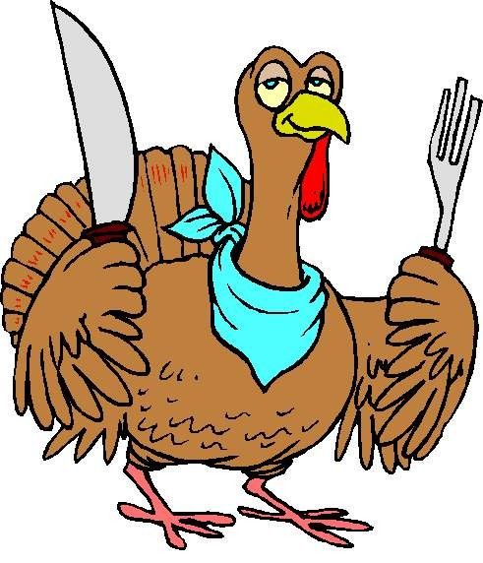 November 2023
Sunday | Monday | Tuesday | Wednesday | Thursday | Friday | Saturday
 |  |  | 1  10-5 | 2  10-5 | 3  10-5 | 4  10-4
5   | 6  10-5 | 7  10-5 | 8  10-5 | 9  10-5 | 10  10-5 | 11  10-4
12 | 13  9-6 | 14  9-6 | 15  9-6 | 16  9-6 | 17  9-6 | 18  9-4
19 | 20  8-6 | 21  8-6 | 22  8-6 | Thanksgiving 23 | 24  10-2 | 25  10-2
26 | 27  10-6 | 28  10-6 | 29  10-6 | 30  10-6

